CISD T-TESS TECH MATRIX

 | 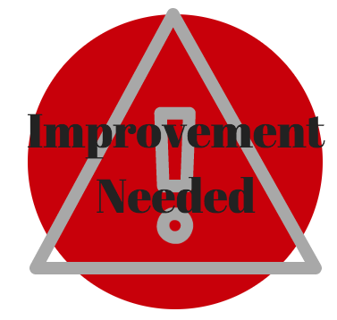  The Teacher begins to incorporate technology into lessons in a basic form | 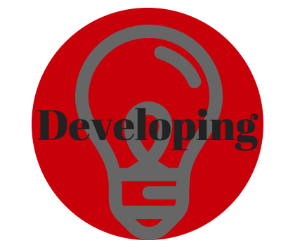  The teacher instructs students on how to use tech. Students are consumers of technology | The teacher directs students to various technology resources | 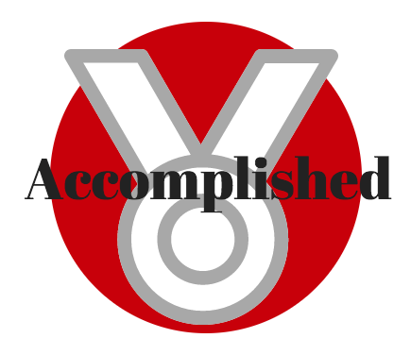  The teacher provides learning opportunities giving students choices in technology | 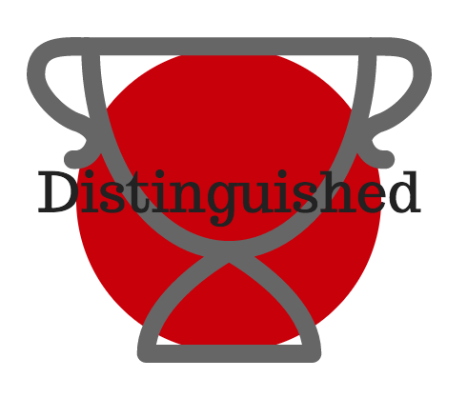  The teacher provides learning opportunities that would not be possible without tech
Domain  1  Planning | Tech resources are added as afterthought; not included in planning | Limited tech resources are used in planning | Technology resources are aligned to fit instruction | Tech is integral part of planning; a variety of resources are considered | Plans take learning to a level impossible without technology
Domain  2  Instruction | Teacher  Centered/No choices. Step-by-step instructions are given | Teacher Centered/Little to no choice/Consumers of technology | Student Centered/Have some choice. Some assignments are delivered electronically | Student Centered/Producers with choice. Electronic delivery of assignments | Student Centered/Producers/clear choice  Electronic delivery and grading of assignments
Domain  3  Learning Environment | Little evidence that technology is provided by district | Organization and usage of technology are sparse. Some tech resources are visible | Students are engaged in relevant collaborative learning groups. | Tech resources are visible in the classroom and students are actively engaged with little teacher direction | Students are delivering and producing content
Domain  4  Professional Practices &Responsibilities | No set goals or knowledge of the district initiatives | Lacking a clear set of goals or drive to grow with the vision of CISD | Goals are set and teacher participates in PD. Teacher communicates the vision of CISD | Teacher exceeds set goals and effectively communicates the vision of CISD | Teacher is a known expert in technology and provides peers with PD opportunities

