Crosby middle School
Student handbook
2015-2016

Home of champions

Crosby Middle School Administration

281-328-9264

Todd Hicks, Principal
Trish Franta, Associate Principal

Alex Sanchez, 8th Grade Assistant Principal Shaunice Pitre, 7th Grade Counselor
Holli Pharis, 7th Grade Assistant Principal Robin Creed, 8th Grade Counselor
Crosby ISD Administration: (281) 328-9200
Crosby ISD Transportation: (281) 328-9248

Crosby Middle School

Alma Mater
Hail to Thee, our Crosby Middle School
Guide and guardian thou shalt be;
Through the years our memories linger
Ever trusting, true to thee.

Love and guide us and protect us
With thy endless loyalty;
Hail to Crosby’s Alma Mater,
Ever true we’ll be to thee.

School Mascot
Cougar

School Colors
Red and White

Fight Song
Onward to victory, never give in;
Fight to the finish, that’s how to win.
Only the best, boys, with all your might;
For Crosby and Alma Mater
Fight, fight, fight, fight!

Onward and upward
Let’s all begin
With such a motto
We’ll always win.
We’ll never falter
We’ll always fight
For Crosby’s Red and White
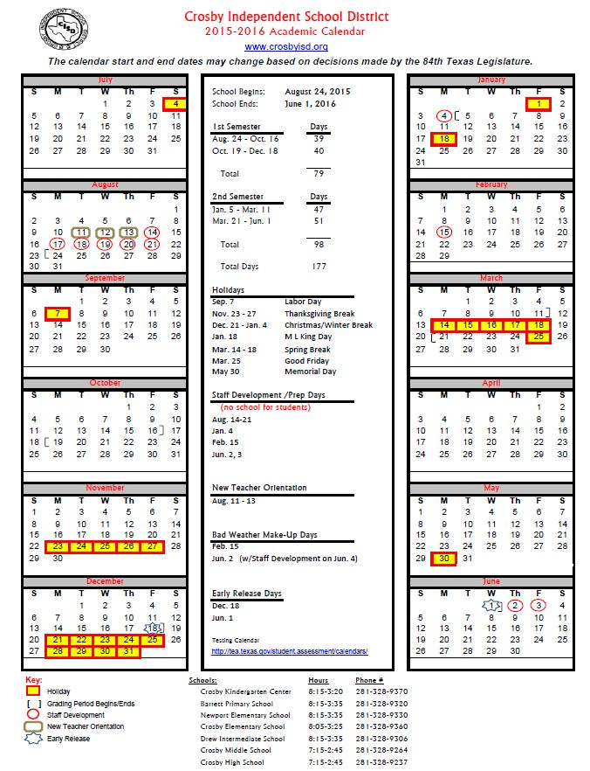

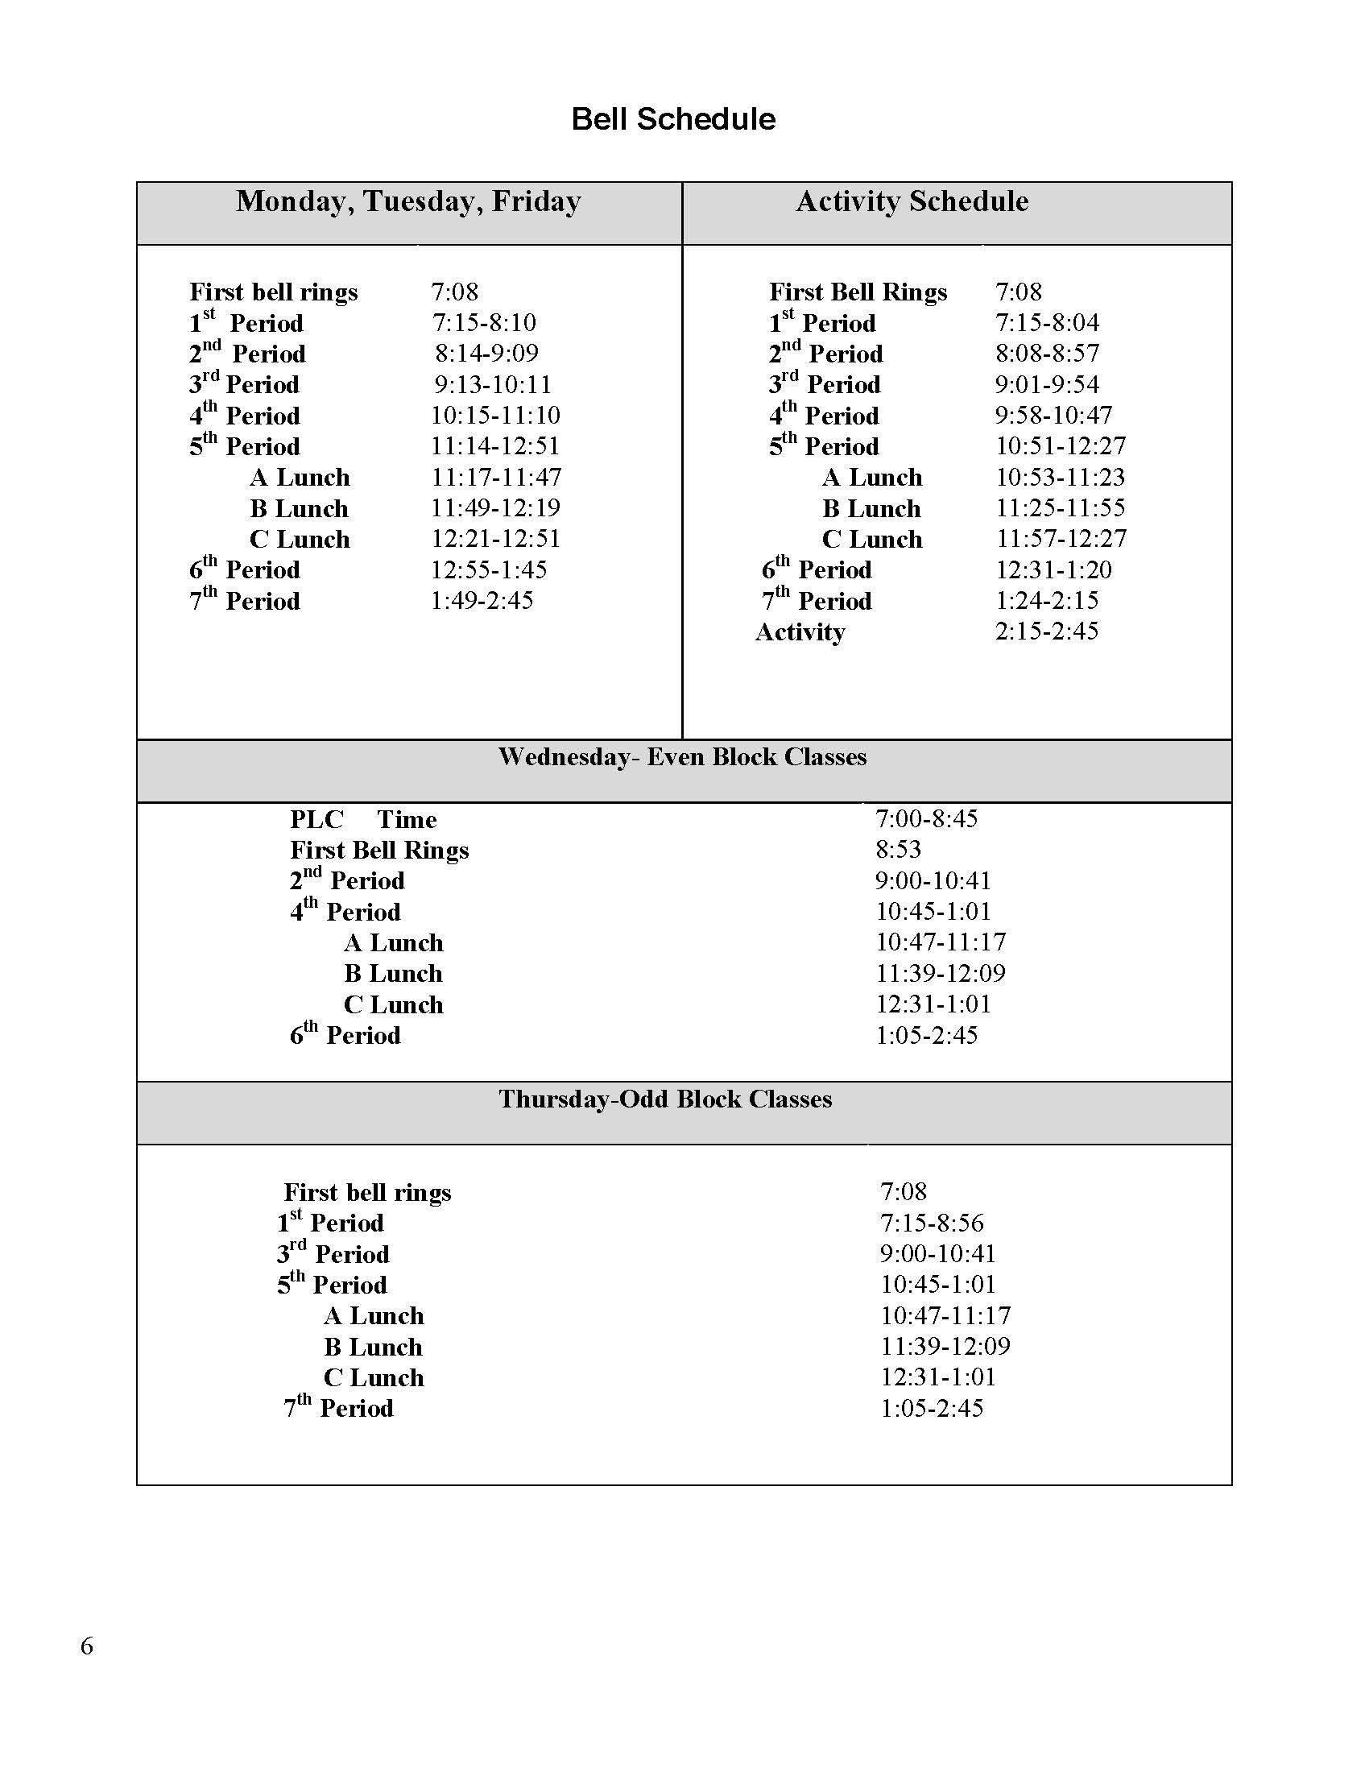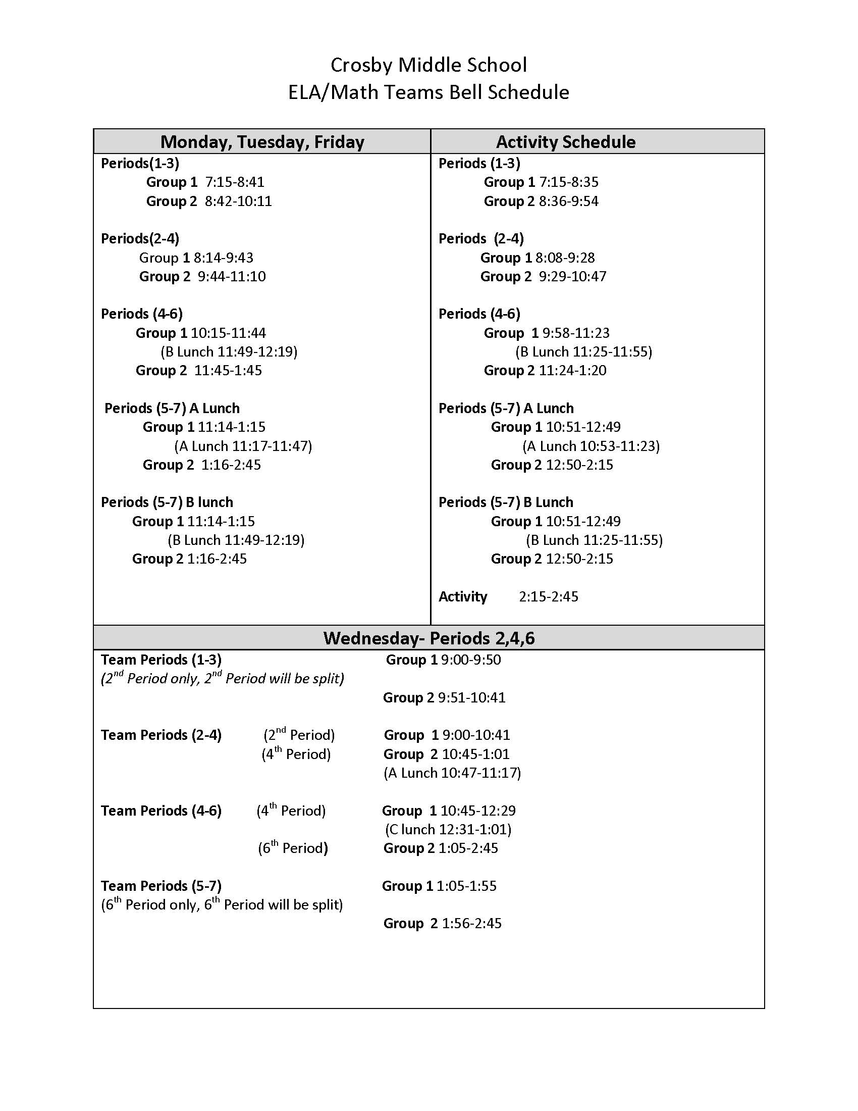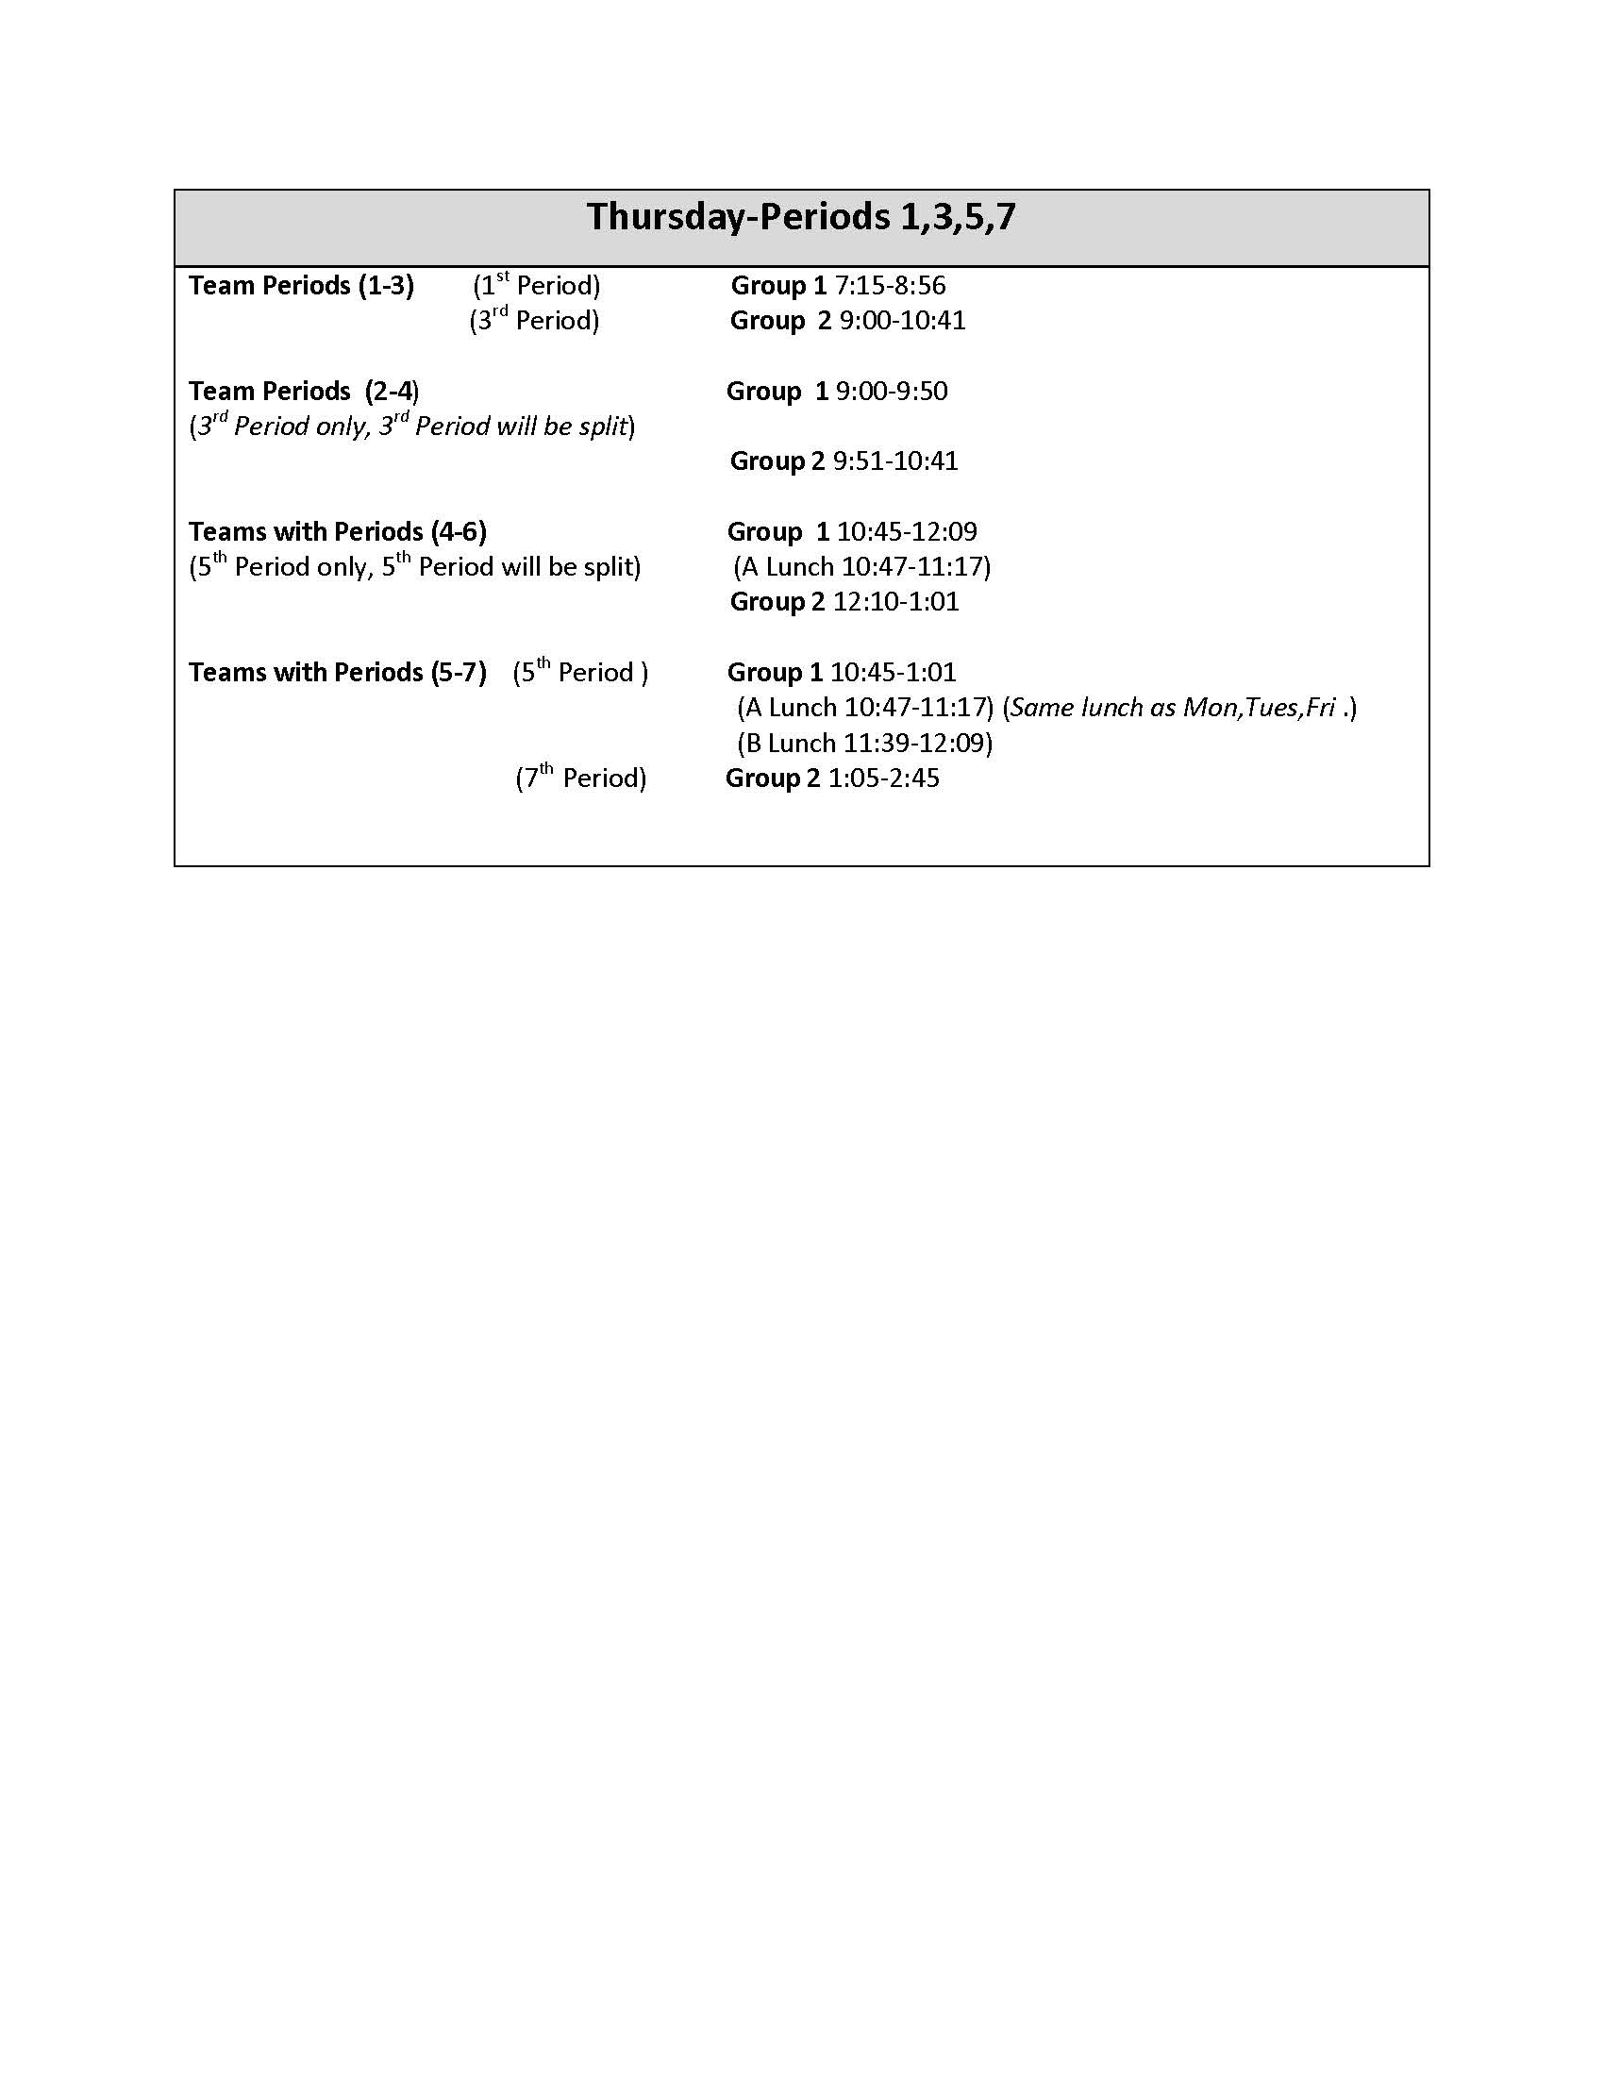

Dear Parent and Student:

Welcome to the 2015-2016 school year! Education is a team effort and we know that students, parents, teachers, and other staff members working together will make this a successful year for our students. The Crosby Middle School Parent/Student Handbook is designed to provide a resource for some of the basic information that you and your child will need during the school year.
We encourage parents to review the entire Crosby Middle School Handbook, as well as the District Student Handbook and the Student Code of Conduct with their child. These handbooks can be used as a reference during this school year. If you or your child have questions about any of the material in this handbook, please contact a teacher, counselor, or school administration. Also, please complete and return Appendix V (Parent Summary Signature Form) by August 28, 2015. Thank you in advance for your cooperation in returning this form.

Quick Reference
Arrival and Release of Students from Campus……. Page 8
Athletic Code……………………………………….. Page 8
Awards and Honors……………………………….... Page 8
BYOD (Bring Your Own Device)………………….. Page 8
Cafeteria…………………………………………….. Page 9
Class and School Officers………………………….. Page 10
Class Schedules…………………………………….. Page 10
Counseling………………………………………..... Page 10
Conduct…………………………………………….. Page 11
Deliveries to Campus………………………………. Page 11
Disciplinary Consequences………………………… Page 11
Dress and Grooming……………………………….. Page 12
Grading Guidelines……………………………….... Page 13
Library…………………………………………….... Page 13
Immunizations……………………………………... Page 13
Locker………………………………………………. Page 14
Parent/Legal Guardian Conference………...…....... Page 14
Parental Involvement………………………...……. Page 14
Parent/Student Complaints/Concerns……………... Page 14
School Facilities………………...………………….. Page 14
School Social Functions/8th Grade Social Rules…... Page 14
STAAR Testing…………………………………..... Page 15
Student Fees……………………………………....... Page 15
Summer School………………………………….…. Page 15
Tardy Policy…………………………………….…... Page 15
Teacher Planning Period……………………….…... Page 15
Telephones……………………………………….…. Page 15
Textbooks………………………………………....... Page 16
Tutorial Program……………………………........... Page 16

ARRIVAL AND RELEASE OF STUDENTS FROM SCHOOL

Signing In & Signing Out
Students must come through the attendance office and sign in when coming to school after 7:15 a.m., regardless of the time of day. Students will be considered tardy upon arriving after the beginning of the school day. There are no excused tardies to first period classes for those students who assume responsibility for transportation to school. After the first fifteen minutes of the school day or after the first fifteen minutes of any class period, the student will be counted absent for that period. If your child is counted absent, please send a note to the attendance office. Anyone not signing in with the office will be considered truant for any class he/she misses.

To receive an early dismissal during the school day, parents must enter the school, check in with the attendance office, and sign-out the student. Only those on the emergency card will be allowed to remove a student from campus. A Driver’s license/state identification card must be presented to the attendance clerk for verification. Students who are assigned in-school suspension and check out during the school day will not receive credit for the day when signed out early, unless approved by an administrator.

ATHLETIC CODE

The expectation for all athletes at Crosby Middle School is to play the game in a spirit of fairness and clean sportsmanship and to observe all rules and regulations of the game. We must accept decisions of officials without protest and treat our opponents as our guests, putting clean play and sportsmanship above victory. We must realize the ability to win without boasting and to lose without grudging. The important elements in sports are striving to excel and the good feelings fostered among participants who have no excuse when they lose.

Academic Eligibility for Athletics
In order to participate in athletics, students are expected to remain academically eligible. Crosby ISD follows the UIL eligibility calendar available online at http://www.uiltexas.org/ or by requesting it from each campus at the start of the school year.

Awards and Honors

Each year, numerous students receive recognition and honors in a variety of areas. Some of the honors students receive are based on academic accomplishments, some by popularity, and some because of accomplishments in specific areas.

Honor Roll
To make the “A” honor roll, a student must make all “A’s” during a nine week marking period, regardless of the level of the class. To make the “All A/One B” honor roll, a student must make only one B in one class during a nine week marking period, with the rest of the grades being all A’s. To make the A/B honor roll, a student must not receive a grade below a B during the nine week period. To receive the All A Honor Roll award at the end of the school year, a student must make all “A’s” in all classes, all year long, regardless of the level of the class. To receive the end-of-year honor roll award, students must maintain all “A’s” and no more than one “B” in all classes taken.

Perfect Attendance
A student must attend all seven-class periods each day to receive a perfect attendance award at the end of the school year. If a student checks out of school prior to the end of the school day, he/she will be ineligible for the award.

BYOD (Bring Your Own Device)
Crosby ISD is now offering a filtered CISD Wi-Fi for Crosby High School and Crosby Middle School. Students in grades 7-12 may bring a personal device to school to use for educational purposes. Students are expected to connect to the filtered CISD Wi-Fi to ensure access to the best online resources.

Important Facts

- Students in grades 7-12 may now bring their own technology devices (laptop, netbook, cellphone, tablet, etc.) to Crosby High School and Crosby Middle School where they will be utilized in the classroom at the discretion of the teacher.

- Users of the CISD Wi-Fi network have filtered Internet access just as they would on a district owned device.

- Crosby ISD offers many educational resources via the Internet. These resources can be accessed anytime, anywhere the student has access to the Internet; thereby, extending learning beyond the classroom.

- By Connecting to the CISD Wi-Fi, users accept the terms of Crosby ISD Responsible Use Guidelines (RUG).

- Use of technology is a privilege and not a right.

- Students are expected to exhibit digital responsibility and follow the Responsible Use Guidelines (RUG) while using technology.

The Responsible Use Guidelines (RUG) may be found on crosbyisd.org and a copy will be provided to your student.

Responsibility for Devices

- The technology devices students bring to school are their sole responsibility.

- The campus or district assumes no responsibility for personal devices if they are lost, loaned, damaged, or stolen and only limited time or resources will be spent trying to locate stolen or lost items.

- Personal devices may be subject to investigation in accordance with District Policy.

- Students are to keep their devices secure at all times and not loan to others.

- Students must keep devices on silent or vibrate mode.

Appropriate Student Use
As with any tool, there are appropriate places and times for the use of devices on the CISD Wi-Fi network. Below are the levels and permissible situations for use. Campus administrators and teachers have the right to prohibit use of devices at certain times or during designated activities (i.e. campus presentation, theatrical performance, or guest speaker) that occur during the school day.

Devices are only to be used:

- When designated for instructional purposes by teacher or other school official.

- During lunch/before school
Devices are not to be used:

- Without direction from teachers or school officials.

- During passing periods

Students who do not have access to personal devices will be provided with an alternative way of completing the assignment or a district owned device may be provided, based on availability.

Tips for Success with CISD Wi-Fi
- Clearly label all devices and power cords with your
student’s name.
- Set a password or passcode on the device.
- Bring devices to school fully charged and in good working
order.
- Record the serial number and model information at home.
- Students may bring headphones to use with their device, as
many digital resources have audio.
- Students should silence or place devices on vibrate while
working in class.

Responsible Use of Technology

Other important guidelines to share with your child about Digital Citizenship and safety are:

- Use strong passwords.
- Do not share passwords.
- Keep addresses, phone numbers, and other personal information private.
- Be respectful when communicating.
- Do not connect with people you do not know personally.
- Students are expected to connect to the filtered Crosby ISD Wi-Fi while on campus.
- Report any suspicious information to an adult immediately.
- Photos are to be taken only when directed by the classroom teacher.
- Students must not loan or share personal devices with others.

Student consequences for violating this policy:
  - The electronic device will be confiscated and will only be released back to the parent.
  - Failure to surrender a device when requested by a teacher or other school official will result in an automatic 2 day ISS assignment.
  - Repeated occurrences of the same issue will result in further punishment.
  - The bus is an extension of the classroom and the same rules apply to students while on the bus.

Any electronic device not claimed by a parent must be picked up by the student on the last day of the school year. Any disciplinary action will be in accordance with the Student Code of Conduct.

CAFETERIA

Cafeteria Policies
- All students will be escorted to the cafeteria and seated by their 4th or 5th period teacher.
- Students should stand in line and not save places or allow others to cut.
- Students may talk or visit with friends, but should avoid shouting or “horse-play.”
- Trays and paper must be removed from the table by the student who used them or by the last student to leave the table. STUDENTS NOT ADHERING TO THESE GUIDELINES WILL RECEIVE A MINIMUM DISCIPLINARY ACTION OF A DETENTION.
- Place all garbage in the containers provided in the commons.
- Students at no time may take food or drink into a classroom or corridor.
- Food deliveries are not to be delivered to the school.
Students should strive to keep the commons neat and clean for their own sake and in appreciation of those who provide these facilities and services.

Breakfast
Breakfast is served on Monday, Tuesday, Thursday, and Friday from 6:50 a.m. – 7:20 a.m. and on Wednesday from 8:40 a.m. – 9:00 a.m.

Lunch
Regular Bell Schedule: Monday, Tuesday, Friday
A Lunch 11:17-11-47
B Lunch 11:49- 12:19
C Lunch 12:21-12-51
Block Bell Schedule: Wednesday & Thursday
A Lunch 10:47-11:17
B Lunch 11:39-12:09
C Lunch 12:31-1:01

CLASS AND SCHOOL OFFICERS

Class and school officers are defined as officers of each class and the student council. To run for one of these offices, candidates must meet the following:
- Must have had at least a “C” average for the previous semester and maintain at least a “C” average in the current semester (summer school not included).
- Must have been enrolled in Crosby Middle school at least three of the last four months of school and be officially registered at the same time of filing for office.
- The student must maintain a good disciplinary record by not having a Category II or greater offense. If the student has one Category II or greater offense, he/she will then be removed from office, as determined by the principal and sponsors.
- Should an officer drop below a “C” average during the semester, he/she will be placed on probation until the next grading period. If he/she still has less than a “C” average, he/she will be removed from office in a manner determined by the principal and sponsors. An officer, who is failing a subject at the end of the first semester, regardless of his/her overall average, is ineligible to hold office during the subsequent semester.

It is the duty of the sponsor to check the eligibility of each candidate for office. If the student should be elected to an office for which he/she is not eligible, it is his/her responsibility to resign immediately upon learning of his/her ineligibility. The office vacated will then be filled by the student who had the next largest amount of votes in the election.

Class and School Officer Election Procedures
Students who meet the qualifications for office, as set forth herein, may pick up an application form from the Student Council sponsor and file for the office they seek. The eligibility of each applicant will be verified and a ballot containing the names of all eligible candidates who filed for each office will be prepared. In the event no single candidate receives a majority of the votes cast, a run-off election will be held between the top vote getters for the office.

CLASS SCHEDULES

All students from each grade must be scheduled into six (6) classes including two (2) electives each year. Class schedules are issued through the counselors’ office.

Regular Class Schedule Changes
Students are enrolled into classes based on their selection of courses and/or academic need. The master schedule is prepared around the number of students requesting a class. A change in one student’s schedule can result in overcrowding of other classes. Students are discouraged from changing a class. In the rare event that a class schedule change is necessary, changes must be submitted on a schedule change form and signed by a parent. Students may obtain forms from the counselors’ office. The procedure for schedule changes may include the following:

- Student and/or parent must conference with the teacher
- Teacher approval (dropping)
- Department chair approval
- Principal approval

Pre-Advanced Placement Schedule Changes
Students enrolled in any pre-advanced placement classes must remain in the class until the end of the semester unless the teacher recommends the change. However, students enrolled in Pre-AP Math courses will be removed from the course if they fail a grading period. Students can be removed from other Pre-AP courses if they do not maintain satisfactory performance, at the discretion of the principal. Students must maintain certain standards that are explained in the course contract in order to remain in a Pre-Advanced Placement class. Students and parents will be advised of the course requirements. Please be advised that guidelines may vary by departments, so students and parents are advised to review the guidelines periodically.

COUNSELING

Academic Counseling
Students and their parents are encouraged to talk with a school counselor, teacher, or principal to learn about course offerings. Each spring, students in both grades will be provided information on anticipated course offerings for the next year and other information that will help to make the most of academic opportunities.

Personal Counseling
The school counselor is available to assist students with a wide range of personal concerns, including such areas as social, family, emotional issues, or substance abuse. The counselor may also make available information about community resources to address these concerns. A student who wishes to meet with the counselor should contact the Guidance Department secretary.

Please note: The school will not conduct a psychological examination, test, or treatment without first obtaining the parent’s written consent, unless required by state or federal law for special education purposes or by the Texas Education Agency for child abuse investigations and reports.
[For more information, refer to policy FFE and FFG(EXHIBIT).]

CONDUCT

General Classroom Procedures
Students will follow these general classroom procedures while on campus. However, these procedures do not exclude any additional classroom rules that the individual teacher might establish.
- Be in the classroom when the tardy bell rings.
- Always have the necessary books and materials ready to begin work.
- Stop talking when the teacher calls the room to attention.
- Address all teachers and staff members as Miss, Mrs., or Mr., and in no case by their first or last name.
- Each student is expected to show respect and courtesy, and follow the direction of those in charge by raising his/her hand and being recognized before speaking.
- Students will maintain a neat and clean classroom at all times. The responsibility for good housekeeping will be shared by all who use the same desk and classroom. At no time will student write on walls, desks or other furniture.
- When the bell rings ending a class period, the teacher will dismiss the students. Students will remain seated until dismissed, and then file out in an ORDERLY manner.

Extracurricular activities
Participation: extracurricular activities are a privilege and not a right. Student conduct, both inside and outside of school hours, can result in suspension from or removal from any and/or all extracurricular activities at the discretion of the coach, sponsor and/or administrator.
Sporting events: spectators and audience members are expected to display behavior that is positive and supportive to both the home and away teams. Game officials, administrators, campus officials, and/or law enforcement officials maintain the authority to remove any spectator at their discretion.

School Events
School rules apply to all school social events. Should a student
bring a guest, they will be expected to observe the same rules as
students attending the event. The person inviting the guest will
share responsibility for the conduct of the guest. A student
attending a social event will be asked to sign out when leaving
before the end of the event; anyone leaving before the official end
of the event will not be readmitted.

Assemblies
Students are expected to sit in assigned sections and to observe good manners in assemblies. Those who cause a disturbance or disruption are subject to appropriate disciplinary action. The following examples of good conduct should be observed by all:
- Enter quickly and quietly and take seats in assigned sections in an orderly manner.
- Give courteous attention to the program.
- Express courtesy and/or approval by polite applause when appropriate.
- Refrain from talking during the entire assembly.

Conduct Before and After School
Teachers and administrators have full authority over student conduct at before-school and after-school activities on district premises and at school-sponsored events off district premises, such as play rehearsals, club meetings, athletic practice, and special study groups or tutorials. Students are subject to the same rules of conduct that apply during the instructional day and will be subject to consequences established by the Student Code of Conduct or any stricter code of conduct (for extracurricular participants), as established by the sponsor, in accordance with Board policy.

Loitering or standing in the halls between classes is not permitted. During class time, a student must have a hall pass to be outside the classroom for any purpose. Failure to obtain a pass will result in disciplinary action in accordance with the Student Code of Conduct.

DELIVERIES TO CAMPUS

Food, flowers and/or gifts for students are not to be delivered to the school by any company or individual.

DISCIPLINARY CONSEQUENCES

Lunch Detention
Lunch detention may be assigned by administrators and staff for minor disciplinary infractions. Failure to attend lunch detention will result in further disciplinary actions.

After-School & Teacher Detentions
For minor classroom infractions, students may be assigned a teacher detention to be served before or after school with that specific teacher. Teachers will notify the student and the parent, whether in writing or by phone call. If a student does not make prior arrangements to attend the detention, and misses the assigned detention, the student will then receive a referral to the front office to serve a minimum of a one-hour detention. In cases where the student has missed multiple detentions for the same teacher, a two-hour detention will be assigned. If a student misses a 2 hour detention, an ISS assignment may be issued to the student.

When a student is assigned to a detention, attempts are made to contact the parent, whether by phone call or notice sent home with the student. Detention times may be changed by the parent when practicable by notifying the discipline office at 281-328-9264 ext. 1705, whether by phone call or note sent with the student. Detentions will be held at the following times:

Monday & Wednesday- 2:45 – 3:45pm
Wednesdays- 2:45 – 4:45pm

In the event that a student is assigned a detention and he/she misses the detention for the assigned date, he/she may be assigned to ISS the following day. In rare instances, other accommodations may be made by directly contacting the principals (i.e. isolated lunch, cafeteria duty, community service hours, etc.).

In-School Suspension
This program serves students in both 7th and 8th grade who have committed offenses that are categorized as serious or persistent. The ISS classroom is located within the school building, and students may be placed in ISS for an indefinite period of time (length of assignment is determined by Board Policy, seriousness of offense, and the attitude of the student). If the conduct occurred during the final nine weeks report, the removal may extend beyond the beginning of the next semester.

The objectives of the ISS program are to:
- Place the student in a highly structured environment so that he/she will not have as great of an opportunity to persist in continued misbehavior.
- Provide the student an opportunity to realize that his/her behavior is unacceptable; and if it persists, the student will be considered for more severe disciplinary measures (suspension or alternative school).
- Provide the student the opportunity to be disciplined without any scholastic penalties.

Upon assignment, the student will be provided with a code of conduct regulating his/her behavior while in ISS. The student must adhere to this code of conduct during his/her period of assignment, as well as all other school rules. Failure to comply with the rules will result in further disciplinary action as deemed by the principal.
In the rare cases that ISS does not prove to be a deterrent to a student’s persistent misbehavior, placement in the Alterative School will be the next step. Once a student has accumulated 20 days in ISS, they will automatically be considered for alternative placement. For more information about disciplinary consequences see the District Code of Conduct.

In addition to the District Code of Conduct, the following subsections set forth your rights and responsibilities to individuals and property.

FOR FURTHER INFORMATION REGARDING STUDENT CONDUCT AND CONSEQUENCES PLEASE REFER TO THE CISD STUDENT CODE OF CONDUCT.

DRESS AND GROOMING

The district’s dress code is established to teach hygiene, instill discipline, prevent disruption, avoid safety hazards and assert authority. Students shall come to school clean, neat, well-groomed and wearing clothing that will not endanger the health or safety of the student or others.
The staff of the school is charged with enforcement of the District’s Dress and Grooming Code. Interpretation of these codes is entirely within their judgment. Final determination of acceptable dress and grooming rests with the principal or his/her designee. The Dress and Grooming Code includes the following requirements:
- The primary goal: Students must dress neatly and modestly.
- Hair: The hair must be neat, clean, and well groomed. No type of head covering, cap or hat is to be worn. Hair rollers or combs may not be worn in the hair. Hair cannot be dyed any color other than a natural color (i.e., green, blue, orange, purple, pink, etc.) and distracting hair styles will not be permitted.
***NOTE: Distracting hair styles will be defined by the principal.
- Facial Hair: Mustaches are allowed that do not extend beyond the corners of the mouth; however, the wearing of a beard/goatee is not acceptable. Sideburns may not extend below the bottom of the earlobe. Students are expected to shave as often as the situation dictates in order to maintain good grooming. NO CUTS OR RAZOR MARKS CAN BE MADE IN THE EYE BROWS!
- Dresses/Skirts: Skirts must reach below mid-thigh when arms are at full extension down by one’s side. Slits in dresses/skirts must conform to the mid-thigh rule. When seated, skirts must remain at mid-thigh. Garments should not fit tightly. Sleeveless dresses, blouses, or tops are not allowed (this includes spaghetti straps and tank tops even if covered by another garment). No pajamas or sleepwear is allowed.
- Pants: Slacks and jeans are appropriate. Slits/cuts or fringed openings are not permitted above the knee, even with garments underneath; holes must be patched. Pants must be worn at the waist. Excessively baggy pants that prohibit students from moving in a regular manner or that require the student to hold their pants up will not be permitted. Pants should not be form-fitting (i.e. tights). Form-fitting pants are considered hosiery and must be covered by a skirt, shorts, or dress of the appropriate length. No leggings are allowed. Words on the rear end section of pants are not allowed.
- Shorts: Shorts must reach below mid-thigh when hands and arms are at full extension along one’s sides and when seated. No slits/cuts or fringed openings are allowed. Walking shorts or dress shorts are advisable. Wind shorts, boxer shorts or biker shorts/tights are not allowed. Words on the rear end section of shorts are not allowed.
- Shirts/Tops: Shirts should be buttoned (except for the neck button) or zipped to the same appropriate height. Length must be so that no torso skin is visible. Tank tops, muscle shirts, or cut-off shirts are not permitted. All boys’ shirts must have sleeves. All girls’ blouses, dresses, and tops must be at least 3 inches across the shoulder. Sheer or see-through type blouses may not be worn. Shirts cannot be tied in the back where skin will be showing. There should be no holes in shirts and any opening should not reveal private parts of one’s body or undergarment. Off the shoulder shirts are not permitted. Shirts with references to violence, drugs, gangs, obscene gestures, lewd suggestions, etc. will not be permitted. Discretion is reserved for the principal.
- Garment/Jewelry: Students may not wear any clothing or accessory that identifies that student as a gang member or member of an unauthorized group. Garments/jewelry bearing any insignia, writing or emblems representing alcohol, drugs, or tobacco products are not permitted. Any garment/jewelry depicting offensive, suggestive, lewd, illegal, violent, or profane writing, emblems, comments or designs are not permitted. Any garment/jewelry that causes a class disruption will be deemed inappropriate. Rosary beads are not allowed to be worn visibly on campus.
- Footwear: Shoes must be appropriate for school. Beachwear and casual shoes, such as house shoes, slippers, water shoes, etc., are not appropriate. Backless sandals may be worn at school, provided they are appropriate.
- Coats/Costumes: Heavy outdoor coats or overcoats should not be worn in the commons or classroom, but stored in the locker. Wearing a costume, cape, mask, gown, etc. is not allowed.
- Backpacks: All backpacks must be stored in one’s locker throughout the school day. A backpack is defined as any item that can be used to store a student’s books or notebooks. Backpacks may not display profanity or vulgar language, obscene gestures, or symbols signifying gang affiliations.
- Sunglasses: Non-prescription glasses with dark lenses, shades or sunglasses are not to be worn.
- Body Rings/Tattoos: Students with body markings must have them covered. Body piercings shall be limited to the ears only. No student shall wear jewelry such as nose rings, tongue rings, eyebrow rings or other items (i.e., chains, spikes, choke collars, dog collars, etc.) deemed inappropriate by the principal or his/her designee.
- Hats: All hats must be placed in the student’s locker throughout the school day.

IT IS THE RESPONSIBILITY OF THE STUDENT TO ENSURE COMPLIANCE WITH DRESS CODE REGULATIONS. FAILURE TO DO SO WILL RESULT IN DISCIPLINARY ACTION. PERSISTENT DRESS CODE VIOLATIONS WILL RESULT IN THE APPROPRIATE DISCIPLINARY ACTION FOR REFUSAL TO COMPLY WITH SCHOOL POLICIES AND DISRUPTION OF THE LEARNING ENVIRONMENT.

THE ADMINISTRATION MAINTAINS THE RIGHT TO DETERMINE ACCEPTABLE FORMS OF DRESS BASED ON DISRUPTION OR DISTRACTION OF THE LEARNING ENVIRONMENT.

Dress Code Violations
When possible, students will be given the opportunity to correct the violation. Upon availability, the school will offer CMS t-shirts to replace inappropriate clothing, parents can be contacted to bring more appropriate attire, or students can change into other clothing they may have. However, if nothing can be done to correct the student’s violation, they will be assigned to ISS for the school day in order to limit distraction to the educational process.

When a student becomes a persistent dress code violator, additional days of ISS will be assigned.

GRADING GUIDELINES & DEPARTMENT POLICIES
Each department has grading guidelines for students. Listed below are the departmental policies for each subject area. Your child will be given a syllabus from each class noting any differences and more detailed explanation of the grading guidelines when they enroll in the class. The school year is divided into 4 9 week grading periods. Each 9 week grading period consists of one report card in addition to 2 progress reports to be delivered home with the student.
Please refer to the following table for distribution of weight in assignments per subject; FOR FURTHER INFORMATION PLEASE REFER TO THE CISD STUDENT HANDBOOK.
Math Department | Social Studies Department | Science Department
7th Grade Math  Tests -50%  Daily- 50%  8th Grade Math  Tests - 60%  Daily- 40% | 7thGrade  Tests - 50%  Daily - 50%  8thGrade  Tests - 60%  Daily - 40% | 7th grade:  Tests-50%  Daily-50%  8th grade:  Tests – 60%  Daily – 40%
7th Grade ELA | 8th Grade ELA
All Classes:  Tests - 50%  Daily - 50% | All Classes:  Tests - 60%  Daily - 40%

IMMUNIZATIONS

The following immunizations are required before a student may
attend school:
- 1 dose of Meningococcal Vaccine (MCV)
- 2 doses of Varicella Vaccine or documentation of Chicken
Pox disease history.
- 1 dose of Tdap/Td within the last 5 years

LIBRARY
The library is a learning laboratory with books, computers, magazines, and other materials available for classroom assignments, projects, and reading or listening pleasure. The library is open for student use during the following times: before school, during lunch, and after school until 3:30 p.m. A pass from a teacher or administrator is required to enter the library.
- Upon arrival, students must present their pass and sign their names and arrival time on the Library Sign-In Log. When leaving, the student must write the time of departure. Each student needs to have an individual pass.
- If using a computer, the student is responsible for that computer during the time he or she is using it.
- Students must know their student number in order to check out a book.
- Regular library books are checked out for two weeks. The teacher sets the due date of class sets of books used by the English or History classes, but housed and issued through the library.
- A fine of $.05 per day per book will be charged on overdue books. The maximum fine per book is $1.00. If a student must pay for a lost or damaged book, the fine is waived. If a lost and paid for book is found and returned in good condition, the cost of the book (less the fine accumulated from the due date until the date the book was paid for) is refunded.
- Quiet behavior is expected.
- No food or drink is allowed.

LOCKER

Lockers will be assigned to all students upon return of all required beginning of the year documentation. All students are required to provide their own lock, and must give their code and/or spare key to Mrs. Rodriguez in the 7th grade office. Students must keep a lock on their locker at all times. If a student forgets his/her combination or key, he/she will need to report to Mrs. Rodriguez.
The school is not responsible for lost or stolen items. Any locks that are placed on lockers that are not assigned to the student will be cut off, and contents will be properly disposed of. Students who are caught sharing lockers, or violating the locker policy, will receive a consequence, which may include the loss of locker privileges.

PARENT/LEGAL GUARDIAN CONFERENCE

The parent/legal guardian is encouraged to conference with their child’s teacher(s) to discuss student progress. In order to do so, the parent should contact the teacher through either an email or a phone call. Go to www.crosbyisd.org to obtain a teacher’s email address. To schedule a telephone or in-person conference, please call the school office at 281-328-9264

PARENTAL INVOLVEMENT

Working Together
Both experience and research tell us that a child’s education succeeds best when there is a strong partnership between home and school; a partnership that thrives on communication. Your involvement in this partnership may include:
- Encouraging your child to put a high priority on education and working with your child on a daily basis to make the most of the educational opportunities the school provides.
- Ensuring that your child completes all homework assignments and special projects.
- Ensuring your child comes to school each day prepared, rested, and ready to learn.
- Becoming familiar with all of your child’s school activities and with the academic programs, including special programs, offered in the District.
- Discussing with the counselor or principal any questions you may have about the options and opportunities available to your child.
- Attending scheduled conferences and requesting additional conferences as needed. To schedule a telephone or in-person conference with a teacher, counselor, or principal, please call the
school office at 281-328-9264 for an appointment. A teacher will
usually return your call or meet with you during his or her
conference period or before or after school.
- Offering to serve as a parent representative on the district-level or campus-level planning committees assisting in the development of educational goals and plans to improve student achievement. For further information, see policies BQA and BQB, and contact the middle school principal at 281-328-9264.
- Attending Board meetings to learn more about District operations. [See policies BE and BED for more information].

PARENT/STUDENT COMPLAINTS/CONCERNS

Student or parent complaints or concerns can be addressed by a phone call or a conference with the teacher or principal. We expect parents to contact the teacher involved. If no resolution is met, the parent is then asked to meet with his/her student’s counselor and/or assistant principal.
If unresolved with the assistant principal, the student and/or parent should schedule a meeting to discuss their concern with the campus principal.

SCHOOL FACILITIES

Use by Students Before and After School
Certain areas of the school will be accessible to students before and after school for specific purposes. Students are required to remain in the area where their activity is scheduled to take place.
The following areas are open to students before school, beginning at 7:00 a.m.: cafeteria, commons, classrooms, library, and clinic.
After dismissal of school in the afternoon, and unless involved in an activity under the supervision of a teacher, students must leave campus immediately.

SCHOOL SOCIAL FUNCTIONS/ 8TH GRADE SOCIAL RULES

- Crosby Middle School sponsors this event.
- Attendees must be enrolled at Crosby Middle School. An eighth grade student may invite one seventh or one eighth grade guest, provided they are students of Crosby Middle.
- Church clothes or Sunday best attire is acceptable. No formal/semi-formal attire for boys or girls. Inappropriate attire will not be admitted.
- The use of a limousine or party bus is not allowed. Students will only be released to their parent/guardian.
- We strongly urge those attending the social to dress according to the theme.
- Mr. & Ms. CMS will be announced.
- All students must register their guests and themselves at the time tickets are purchased.
- Once a student registers and enters the dance, he/she will not be permitted to leave and return for any reason.
- Students MAY NOT attend the social events if:
- He/she is assigned ISS, suspended, or receives a citation during the semester of the event. If a student purchases a ticket and his/her behavior warrants an assignment to ISS, he/she forfeits the cost of the ticket. No refund will be made.
- He/she cannot make transportation arrangements for timely pickup. Transportation either to or from the event will not be provided.
- He/she has any outstanding debts.
- He/she checks out early on the day of the dance.
- He/she is enrolled in alternative school at the time of the dance.

STAAR TESTING
All 7th grade students will be required to take the Math, Reading, and Writing STAAR tests. 8th grade students will be required to take the Math, Reading, Science and Social Studies STAAR tests.

STAAR Testing Calendar
Test Dates | Testing
Tuesday, March 29th | Grade 8- STAAR Math  Grade 7- STAAR Writing Day 1
Wednesday, March 30th | Grade 8- STAAR Reading  Grade 7- STAAR Writing Day 2
Monday, May 9th | Grade 7- STAAR Math
Tuesday, May 10th | Grade 7- STAAR Reading
Wednesday, May 11th | Grade 8- Science
Thursday, May 12th | Grade 8- Social Studies

STUDENT FEES

Materials that are part of the basic educational program are provided with state and local funds and are at no charge to a student. A student, however, is expected to provide his or her own pencils, paper, erasers, and notebooks and may be required to pay certain other fees or deposits, including:
- Costs for materials for a class project that the student will keep.
- Membership dues in voluntary clubs or student organizations and admission fees to extracurricular activities.
- Security deposits.
- Personal physical education and athletic equipment and apparel.
- Voluntarily purchased pictures, publications, yearbooks, etc.
- Voluntarily purchased student accident insurance.
- Musical instrument rental and uniform maintenance, when uniforms are provided by the District.
- Personal apparel used in extracurricular activities that becomes the property of the student.
- Fees for lost, damaged, or overdue library books.
- Fees for optional courses offered for credit that require use of facilities not available on District premises.

Any required fee or deposit may be waived if the student and parent are unable to pay. Application for such a waiver may be made to the principal. [For further information, see policy FP.]

SUMMER SCHOOL

Academic criteria for promotion:
- In Grades 1-8, promotion is based on an overall average of 70 on a scale of 0-100.
- Students Must Pass Math and Language Arts classes with a minimum average of 70. If a student fails either class, they will be candidates for retention and must attend summer school.
- Students’ overall average in the four core subjects of Math, Language Arts, Science, and Social Studies must be a minimum of 70. If a student passes Math and Language Arts, but fails Science or Social Studies with a grade low enough to bring the overall average of the four core subjects to less than 70, he/she will be required to attend summer school.
STAAR criteria for promotion to 9th grade:
Under Texas Law, as set forth in the Student Success Initiative (SSI) grade advancement requirements, students must meet the minimum passing standard on both the Math and Reading STAAR assessments in order to be eligible for promotion to 9th grade. Any student failing to meet the minimum passing standard must participate in required additional instruction in order to be promoted to the next grade. SSI instruction for Math and Reading will take place during Crosby ISD Summer School.

TARDY POLICY

Students will be considered tardy upon arriving after the beginning of the school day. A student will be considered tardy to class when the tardy bell rings and he/she is not in the assigned classroom, following the teacher’s instructions. It will be the student’s responsibility to have a pass to be in the hallway after the tardy bell rings.

Tardies will be cumulative per semester. Consequences for excessive tardies per semester are as follows:

5th Tardy--------------1 hr. after school detention
6th -9th Tardy---------2 hr. after school detention(Wed.)
10th Tardy-------------1 day of ISS

Following the 10th tardy, discipline will be left up to the discretion
of the administration.

TEACHER PLANNING PERIOD

Each teacher has a regularly scheduled planning period during the school day when personal conferences may be held with parents. Parents may arrange for a conference with the teacher by calling the attendance office at 281-328-9264 or by emailing the teacher directly.

TELEPHONES

Students are not allowed to receive personal phone calls during school. A message will be delivered only from a parent or guardian. To leave a message, call 281-328-9264. A student may call home from the front office. A student will not be permitted to leave class to use the phone unless it is an emergency. All other calls may be made between classes or at lunch. In case of sickness or an emergency, the nurse’s phone will be available.

TEXTBOOKS

State-approved textbooks are provided free of charge for each subject or class. After textbooks have been issued, they become the responsibility of the student and his/her parent(s). Students CANNOT transfer responsibility for a textbook by loaning it to another student. A student who is issued a damaged textbook should report the damage to the teacher immediately. Damage to textbooks by students will result in the assessment of a fine, as determined by the campus administration.

A student must return all textbooks to the teacher or principal’s designee at the end of the school year, or when the student withdraws from school. Each student, or the student’s parent, is responsible for each textbook not returned by the student. A student who fails to return all textbooks forfeits the right to free textbooks until each textbook previously issued, but not returned, is paid for by the student or parent. However, a student will be provided textbooks for use at school during the school day. Fines and replacement fees will be collected in the main office.

TUTORIAL PROGRAM

Tutorials will be offered Monday-Thursday from 2:45-3:45.
Subject specific tutorials are listed below:

- Monday- Science
- Tuesday- Math
- Wednesday- Social Studies
- Thursday- English

CROSBY MIDDLE
SCHOOL
Appendix I

Acknowledgment of Receipt of
Crosby Middle School Handbook
2015-2016

Parents and students may access the 2015-2016 Crosby Middle School Handbook by following the steps below or can request a copy from Crosby Middle School.

- Go to crosbyisd.org
- Click Schools
- Click Crosby Middle School
- Click School Policies

I understand that the Crosby Middle School Handbook contains important information that my child and I may need during the school year. I also understand that the school will follow the District Student Code of Conduct in managing student behavior and administering disciplinary consequences for all students.

Please record your acknowledgement that you have received the received a Crosby Middle School Handbook on the Parent Summary Signature Form (Appendix V) and keep this page for your records.

CROSBY MIDDLE
SCHOOL
Appendix II

Parent’s Release of Student Information – School Sponsored Purposes

Crosby ISD has designated the following information as directory information for school-sponsored purposes:
- Student’s name
- Address
- Telephone listing
- Image (e.g., photograph, digital/video image)
- Date of birth
- Honors and awards received
- Dates of attendance
- Grade level
- Most recent educational institution attended
- Participation in officially recognized activities and sports
- Weight and height, if a member of an athletic team

Directory information is identified for limited school-sponsored purposes only and remains otherwise confidential and will not be released to the public without the consent of the parent or guardian.

Please indicate your decision on the parent summary form (Appendix V) and keep this page for your records.

CROSBY MIDDLE
SCHOOL
Appendix III

Parent’s Release of Student Information –Other than School-Sponsored Purposes

For all other purposes, Crosby ISD has designated the following information as directory information:

- Student’s name

- Address

- Grade level
- Image/video (Used to promote school related activities or recognition of students through social media outlets and other mediums).

Please indicate your decision on the parent summary form (Appendix V) and keep this page for your records.

CROSBY MIDDLE
SCHOOL
Appendix IV

Responsible Use Guidelines (Internet/Network)

Students and parents must sign and complete the Responsible Use Guideline and Parent Summary Signature Form, and return to your school.

Crosby Independent School District makes a variety of communications and information technologies available to students through computer/network/Internet access. These technologies, when properly used, promote educational excellence in the District by facilitating resource sharing, innovation, and communication. Illegal, unethical or inappropriate use of these technologies can have dramatic consequences, harming the District, its students and its employees. These Responsible Use Guidelines are intended to minimize the likelihood of such harm by educating District students and setting standards which will serve to protect the District. The District firmly believes that digital resources, information and interaction available on the computer/network/Internet, far outweigh any disadvantages.

Mandatory Review. To educate students on proper computer/network/Internet use and conduct, students are required to review these guidelines at the beginning of each school year. All District students shall be required to acknowledge receipt and understanding of all guidelines governing use of the system and shall agree in writing to allow monitoring of their use and to comply with such guidelines. The parent or legal guardian of a student user is required to acknowledge receipt and understanding of the District’s Student Responsible Use Guidelines for Technology (hereinafter referred to as the Responsible Use Guidelines) as part of their review of the Student Code of Conduct.

Employees supervising students who use the District’s system must provide training emphasizing its appropriate use.

Definition of District Technology System. The District’s computer systems and networks (system) are any configuration of hardware and software. The system includes but is not limited to the following:

- Telephones, cellular telephones, and voicemail technologies;
- Email accounts;
- Servers;
- Computer hardware and peripherals;
- Software including operating system software and application software;
- Digitized information including stored text, data files, email, digital images, and video and audio files;
- Internally or externally accessed databases, applications, or tools (Internet- or District-server based);
- District-provided Internet access;
- District-filtered public Wi-Fi; and
- New technologies as they become available.

Availability of Access

Acceptable Use. Computer/Network/Internet access will be used to enhance learning consistent with the District’s educational goals. The District requires legal, ethical and appropriate computer/network/Internet use.

Privilege. Access to the District’s computer/network/Internet is a privilege, not a right.

Access to Computer/Network/Internet. Access to the District’s electronic communications system, including the Internet, shall be made available to students for instructional purposes. Each District computer and public Wi-Fi (available for students who bring their own personal telecommunication devices) has filtering software that blocks access to visual depictions that are obscene, pornographic, inappropriate for students, or harmful to minors, as defined by the federal Children’s Internet Protection Act (CIPA). Filtered Internet access is provided to students as defined by CIPA.

Student Access. Computer/Network/Internet access is provided to all students unless parents or guardians request in writing to the campus principal that access be denied. Student Internet access will be under the direction and guidance of a District staff member. Students may also be allowed to use the local network and public Wi-Fi with campus permission.

Students 13 or younger. For students under the age of 13, the Children’s Online Privacy Protection Act (COPPA) requires additional parental permission for educational software tools. Parents wishing to deny access to these educational tools must do so in writing to the campus principal indicating their child should be denied access to these tools. Examples of these tools are Discovery Education, wikis, blogs, and Edmodo. These tools can be accessed through the District’s student Webpage.

Use of Personal Telecommunication Devices. The District believes technology is a powerful tool that enhances learning and enables students to access a vast amount of academic resources. The District’s goal is to increase student access to digital tools and facilitate immediate access to technology-based information, much the way that students utilize pen and paper. To this end, the District will open a filtered, wireless network through which students in specific age groups will be able to connect privately owned (personal) telecommunication devices. Students using personal telecommunication devices must follow the guidelines stated in this document while on school property, attending any school-sponsored activity, or using the Crosby ISD network.

Middle School– Students are allowed to bring personal telecommunication devices that can access the Internet for educational purposes as determined by the classroom teacher. Students will not be allowed to use the devices during passing periods. Taking pictures and/or videos for non-educational purposes is strictly prohibited.

Security. A student who gains access to any inappropriate or harmful material is expected to discontinue the access and to report the incident to the supervising staff member. Any student identified as a security risk or as having violated the Responsible Use Guidelines may be denied access to the District’s system. Other consequences may also be assigned. A student who knowingly brings prohibited materials into the school’s electronic environment will be subject to suspension of access and/or revocation of privileges on the District’s system and will be subject to disciplinary action in accordance with the Board-approved Student Code of Conduct.

Content/Third-Party Supplied Information. Students and parents of students with access to the District’s system should be aware that use of the system may provide access to other electronic communication systems in the global electronic network that may contain inaccurate and/or objectionable material.

Subject to Monitoring.
All District computer/network/Internet usage shall not be considered confidential and is subject to monitoring by designated staff at any time to ensure appropriate use. Students should not use the computer system to send, receive or store any information, including email messages, that they consider personal or confidential and wish to keep private. All electronic files, including email messages, transmitted through or stored in the computer system will be treated no differently than any other electronic file. The District reserves the right to access, review, copy, modify, delete or disclose such files for any purpose. Students should treat the computer system like a shared or common file system with the expectation that electronic files, sent, received or stored anywhere in the computer system, will be available for review by any authorized representative of the District for any purpose. Personal telecommunication devices are subject to examination in accordance with disciplinary guidelines if there is reason to believe that the Responsible Use Guidelines have been violated.
Student Computer/Network/Internet Responsibilities
District students are bound by all portions of the Responsible Use Guidelines. A student who knowingly violates any portion of the Responsible Use Guidelines will be subject to suspension of access and/or revocation of privileges on the District’s system and will be subject to disciplinary action in accordance with the Board-approved Student Code of Conduct.

Use of Social Networking/Digital Tools. Students may participate in District-approved social media learning environments related to curricular projects or school activities and use digital tools, such as, but not limited to, mobile devices, blogs, discussion forums, RSS feeds, podcasts, wikis, and on-line meeting sessions. The use of blogs, wikis, podcasts, and other digital tools are considered an extension of the classroom. Verbal or written language that is considered inappropriate in the classroom is also inappropriate in all uses of blogs, wikis, podcasts, and other District-approved digital tools.

Use of System Resources. Students are asked to purge email or outdated files on a regular basis.

Password Confidentiality. Students are required to maintain password confidentiality by not sharing their password with others. Students may not use another person’s system account.

Reporting Security Problems. If knowledge of inappropriate material or a security problem on the computer, network, or Internet is identified, the student should immediately notify the supervising staff member. The security problem should not be shared with others.

The following guidelines must be adhered to by students using a personally-owned telecommunication device at school:
- Internet access is filtered by the District on personal telecommunication devices in the same manner as District-owned equipment. If network access is needed, connection to the filtered, wireless network provided by the District is required.
- These devices are the sole responsibility of the student owner. The campus or District assumes no responsibility for personal telecommunication devices if they are lost, loaned, damaged or stolen and only limited time or resources will be spent trying to locate stolen or lost items.
- These devices have educational and monetary value. Students are prohibited from trading or selling these items to other students on District property, including school buses.
- Each student is responsible for his/her own device: set-up, maintenance, charging, and security. Staff members will not store student devices at any time, nor will any District staff diagnose, repair, or work on a student’s personal telecommunication device.
- Telecommunication devices will not be used as a factor in grading or assessing student work. Students who do not have access to personal telecommunication devices will be provided with comparable District-owned equipment or given similar assignments that do not require access to electronic devices.
- Telecommunication devices are only to be used for educational purposes at the direction of a classroom teacher or as stated for specific age groups.
- Campus administrators and staff members have the right to prohibit use of devices at certain times or during designated activities (i.e. campus presentations, theatrical performances, or guest speakers) that occur during the school day.
- An appropriately-trained administrator may examine a student’s personal telecommunication device and search its contents, in accordance with disciplinary guidelines.

Inappropriate Use

Inappropriate use includes, but is not limited to, those uses that violate the law, that are specifically named as violations in this document, that violate the rules of network etiquette, or that hamper the integrity or security of this computer/network/Internet system or any components that are connected to it. The following actions are considered inappropriate uses, are prohibited, and will result in revocation of the student’s access to the computer/network/Internet.

Violations of Law. Transmission of any material in violation of any federal or state law is prohibited. This includes, but is not limited to:
- threatening, harassing, defamatory or obscene material;
- copyrighted material;
- plagiarized material;
- material protected by trade secret; or
- blog posts, Web posts, or discussion forum/replies posted to the Internet which violate federal or state law.

Tampering with or theft of components from District systems may be regarded as criminal activity under applicable state and federal laws. Any attempt to break the law through the use of a District computer/network/Internet account may result in prosecution against the offender by the proper authorities. If such an event should occur, the District will fully comply with the authorities to provide any information necessary for legal action.

Modification of Computer. Modifying or changing computer settings and/or internal or external configurations without appropriate permission is prohibited.

Transmitting Confidential Information. Students may not redistribute or forward confidential information without proper authorization. Confidential information should never be transmitted, redistributed or forwarded to outside individuals who are not expressly authorized to receive the information. Revealing personal information about oneself or others such as, but not limited to, home addresses, phone numbers, email addresses, or birthdates, is prohibited.

Commercial Use. Use of the system for any type of income-generating activity is prohibited. Advertising the sale of products, whether commercial or personal is prohibited.

Marketing by Non-CISD Organizations. Use of the system for promoting activities or events for individuals or organizations not directly affiliated with or sanctioned by the District is prohibited.

Vandalism/Mischief. Any malicious attempt to harm or destroy District equipment, materials or data;, or the malicious attempt to harm or destroy data of another user of the District’s system, or any of the agencies or other networks to which the District has access is prohibited. Deliberate attempts to degrade or disrupt system performance are violations of District policy and administrative regulations and may constitute criminal activity under applicable state and federal laws. Such prohibited activity includes, but is not limited to, the uploading or creating of computer viruses.

Vandalism as defined above is prohibited and will result in the cancellation of system use privileges. Students committing vandalism will be required to provide restitution for costs associated with system restoration and may be subject to other appropriate consequences. [See the Board-approved Student Code of Conduct.]

Intellectual Property. Students must always respect copyrights and trademarks of third-parties and their ownership claims in images, text, video and audio material, software, information and inventions. The copy, use, or transfer of others’ materials without appropriate authorization is not allowed.

Copyright Violations. Downloading or using copyrighted information without following approved District procedures is prohibited.
Plagiarism. Fraudulently altering or copying documents or files authored by another individual is prohibited.

Impersonation.
Attempts to log onto the computer, network, or Internet to impersonate a system administrator or District employee, student, or individual other than oneself, will result in revocation of the student’s access to the computer, network, and/or Internet.

Illegally Accessing or Hacking Violations. Intentional or unauthorized access or attempted access of any portion of the District’s computer systems, networks, or private databases to view, obtain, manipulate, or transmit information, programs, or codes is prohibited.

File/Data Violations. Deleting, examining, copying, or modifying files and/or data belonging to other users, without their permission is prohibited.

System Interference/Alteration. Deliberate attempts to exceed, evade or change resource quotas are prohibited. The deliberate causing of network congestion through mass consumption of system resources is prohibited.

Email and Communication Tools
Email and other digital tools such as, but not limited to blogs and wikis, are tools used to communicate within the District. The use of these communication tools should be limited to instructional, school-related activities, or administrative needs.

All students in grades 7-12 will be issued email accounts. Students should check email frequently, delete unwanted messages promptly, and stay within the email server space allocations. Email attachments are limited to 2MB or smaller. Internet access to personal email accounts is not allowed. Students should keep the following points in mind:

Perceived Representation. Using school-related email addresses, blogs, wikis, and other communication tools might cause some recipients or other readers of the email to assume that the student’s comments represent the District or school, whether or not that was the student’s intention.

Privacy. Email, blogs, wikis, and other communication within these tools should not be considered a private, personal form of communication. Private information, such as home addresses, phone numbers, last names, pictures, or email addresses, should not be divulged. To avoid disclosing email addresses that are protected, all email communications to multiple recipients should be sent using the blind carbon copy (bcc) feature.

Inappropriate Language. Using obscene, profane, lewd, vulgar, rude, inflammatory, threatening, or disrespectful language in emails, blogs, wikis, or other communication tools is prohibited. Sending messages that could cause danger or disruption, personal attacks, including prejudicial or discriminatory attacks are prohibited.

Political Lobbying. Consistent with State ethics laws, District resources and equipment, including, but not limited to, emails, blogs, wikis, or other communication tools must not be used to conduct any political activities, including political advertising or lobbying. This includes using District email, blogs, wikis, or other communication tools to create, distribute, forward, or reply to messages, from either internal or external sources, which expressly or implicitly support or oppose a candidate for nomination or election to either a public office or an office of a political party or support or oppose an officeholder, a political party, or a measure (a ballot proposition). These guidelines prohibit direct communications as well as the transmission or forwarding of emails, hyperlinks, or other external references within emails, blogs, or wikis regarding any political advertising.

Forgery. Forgery or attempted forgery of email messages is prohibited. Attempts to read, delete, copy or modify the email of other system users, deliberate interference with the ability of other system users to send/receive email, or the use of another person’s user ID and/or password is prohibited.

Junk Mail/Chain Letters. Generally, students should refrain from forwarding emails which do not relate to the educational purposes of the District. Chain letters or other emails intended for forwarding or distributing to others is prohibited. Creating, distributing or forwarding any annoying or unnecessary message to a large number of people (spamming) is also prohibited.

Student Email Accounts and Electronic Communication Tools
Electronic communication is an important skill for 21st Century students. By providing this tool, the District is equipping students with the skills necessary for success in the business world. Students in grades 7 - 12 are given access to a District student email account. Students must abide by the guidelines established for Email and Communication Tools. Student email accounts will be available for use by students in grades 7-12 while they are currently enrolled in the District. Parents wishing to deny access to District email must do so in writing to the campus principal. As appropriate, project email accounts may be granted for educational activities for students in grades K-5 at the request of the classroom teacher. Student email accounts may be provided directly by the District, through the content management system of an approved online course, or through a District-approved provider.

Consequences of Agreement Violation

Any attempt to violate the provisions of this agreement may result in revocation of the student’s access to the computer/network/Internet, regardless of the success or failure of the attempt. In addition, school disciplinary and/or appropriate legal action may be taken.

Denial, Revocation, or Suspension of Access Privileges. With just cause, the System Administrator and/or building principal, may deny, revoke, or suspend computer/network/Internet access as required, pending an investigation.

Warning

Sites accessible via the computer/network/Internet may contain material that is illegal, defamatory, inaccurate or controversial. Each district computer with Internet access has filtering software that blocks access to visual depictions that are obscene, pornographic, inappropriate for students, or harmful to minors, as defined by the federal Children’s Internet Protection Act. The District makes every effort to limit access to objectionable material; however, controlling all such materials on the computer/network/Internet is impossible, even with filtering in place. With global access to computers and people, a risk exists that students may access material that may not be of educational value in the school setting.

Disclaimer

The District’s system is provided on an “as is, as available” basis. The District does not make any warranties, whether expressed or implied, including, without limitation, those of merchantability and fitness for a particular purpose with respect to any services provided by the system and any information or software contained therein. The District does not guarantee that the functions or services performed by, or that the information or software contained on the system will meet the system user’s requirements, or that the system will be uninterrupted or error free, or that defects will be corrected.

Opinions, advice, services, and all other information expressed by system users, information providers, service providers, or other third-party individuals in the system are those of the providers and not the District.

The District will cooperate fully with local, state, or federal officials in any investigation concerning or relating to misuse of the District’s electronic communications system.

BYOD (Bring Your Own Device)
Crosby ISD is now offering a filtered CISD Wi-Fi for Crosby High School and Crosby Middle School. Students in grades 7-12 may bring a personal device to school and use for educational purposes. Students are expected to connect to the filtered CISD Wi-Fi to ensure access to the best online resources.

Important Facts

- Students in grades 7-12 may now bring their own technology devices (laptop, netbook, cellphone, tablet, etc.) to Crosby High School and Crosby Middle School and they will be utilized in the classroom at the discretion of the teacher.

- Users of the CISD Wi-Fi network have filtered Internet access just as they would on a district owned device.

- Crosby ISD offers many educational resources via the Internet. These resources can be accessed anytime, anywhere the student has access to the Internet; therefore, learning is extended beyond the classroom.

- By Connecting to the CISD Wi-Fi, users accept the terms of Crosby ISD Responsible Use Guidelines (RUG).

- Use of technology is a privilege and not a right.

- Students are expected to exhibit digital responsibility and follow the Responsible Use Guidelines (RUG) while using technology.

The Responsible Use Guidelines (RUG) may be found on crosbyisd.org and a copy will be provided to your student.

Responsibility for Devices

- The technology devices students bring to school are their sole responsibility.

- The campus or district assumes no responsibility for personal devices if they are lost, loaned, damaged, or stolen and only limited time or resources will be spent trying to locate stolen or lost items.

- Personal devices may be subject to investigation in accordance with District Policy.

- Students are to keep their devices secure at all times and not loan to others.

- Students must keep devices on silent or vibrate mode.

Appropriate Student Use
As with any tool, there are appropriate places and times for the use of devices on the CISD Wi‐Fi network. Below are the levels and permissible situations for use. Campus administrators and teachers have the right to prohibit use of devices at certain times or during designated activities (i.e. campus presentation, theatrical performance, or guest speaker) that occur during the school day.

Usage | Middle School
When designated for learning by teacher
During Passing Periods
During Lunch /Before school

Specific Procedures will be announced by campuses

Grading of Student Work

Students who do not have access to personal devices will be provided with an alternative way of completing the assignment or a district owned device may be provided based on availability.

Tips for Success with CISD Wi-Fi
- Clearly label all devices and power cords with your
student’s name.
- Set a password or passcode on the device.
- Bring devices to school fully charged and in good
working order.
- Record the serial number and model information at home
- Students may bring headphones to use with their device
as many digital resources have audio.
- Your homeowner’s or renter’s insurance policy may cover
lost or damaged personal electronic devices.
- Students should silence or place devices on vibrate while
working in class.

Responsible Use of Technology

Other important guidelines to share with your child about Digital Citizenship and safety are:

- Use strong passwords.
- Do not share passwords.
- Keep addresses, phone numbers, and other personal information private.
- Be respectful when communicating.
- Do not connect with people you do not know personally.
- Students are expected to connect to the filtered Crosby ISD Wi‐Fi while on campus.
- Report any suspicious information to an adult immediately.
- Photos are to be taken only when directed by the classroom teacher.
- Students must not loan or share personal devices with others.

Crosby Independent School District
Responsible Use Guidelines
(For Students)
First Name _________________________ (M) _____ Last Name____________________________

Grade level____________

We ___________________________________and _________________________________________
(Printed parent name) (Printed student name)
have read the Responsible Use Guidelines, understand, and agree to adhere to the principles and procedures detailed within. We understand and accept the conditions stated in the Responsible Use Guidelines and agree to hold blameless, and release from any liability, the Crosby Independent School District, the sponsoring school, its subcontractors, and employees. We understand that the Responsible Use Guidelines may be revised by the district to respond to the changing environment of web based computer technology; we agree to any revised conditions of the RUG.

We understand that a network user is expected to use good judgment and follow the Responsible Use Guidelines printed in the student handbook published by the school. We further understand that any student who violates any provision of the Responsible Use Guidelines will lose all network privileges on the Crosby ISD network and may be disciplined, as appropriate, for violations of the Student Code of Conduct. We also understand that displaying work on the Internet makes the work available for viewing by any person around the world that has Internet access.

Place a check mark in the appropriate boxes below to complete permission for his or her participation in activities involving the Crosby Electronic Network.

___May access the Internet

___May have their work displayed on the Internet

___May participate in distance learning activities

___May access the Intranet
The Intranet is an internal network of Crosby ISD. This network is not available for public access.

___May have work displayed on the Intranet

NOTE: If any areas are left unchecked in Appendix V, it will be assumed that permission is granted. You must specifically check “no” and sign the Student and Parent Summary Signature form 2015 – 2016 (Appendix V) to deny any access.

Please indicate your decision on the parent summary form (Appendix V) and keep this page for your records.

CROSBY MIDDLE
SCHOOL
Appendix V
Parent Summary Signature Form
2015– 2016
Student Information:
____________________________ ______________________________ ________
Last Name First Name M.I
________________ __________ __________ __________________
ID/Lunch Number Grade Gender Home Phone #

My child and I have been offered the option to receive a paper copy or to electronically access (at www.crosbyisd.org) the Crosby ISD Student Handbook, the District Student Code of Conduct and the Campus Handbook.
I have chosen to:
_________ Receive a paper copy of the Student Code of Conduct, Student Handbook, and Campus Handbook.
_________ Accept responsibility for accessing the Student Code of Conduct, Student Handbook, and Campus Handbook
by visiting the Web address listed above.

I affirm the information included on all enrollment, attendance, and nurse’s forms are correct. I have viewed and read the Crosby Middle School Handbook, District Student Handbook, and District Student Code of Conduct, including the following appendixes, and have indicated my choices below.

Appendix I – CMS Handbook Receipt ___Yes ___No

Appendix II – Parent’s Release of student Information ___Yes ___No
for School- Sponsored purposes

Appendix III - Parent Release of Student Information ___Yes ___No
For other than School Sponsored purposes

Appendix IV-Responsible Use Guidelines: Place a check mark in the appropriate boxes below to complete permission for his or her participation in activities involving the Crosby Electronic Network.

May Access the Internet | ___Yes | ___No
May have their work displayed on the Internet | ___Yes | ___No
May participate in distance learning activities | ___Yes | ___No
May access the Intranet | ___Yes | ___No
May have work displayed on the Intranet | ___Yes | ___No

I understand that the handbook contains information that my child and I may need during the school year and that all students will be held accountable for their behavior and will be subject to the disciplinary consequences outlined in the Student Code of Conduct. If I have any questions regarding this handbook, or the Student Code of Conduct, I should direct those questions to the principal.

________________________ ____________ ________________________ ____________
Parent/Guardian Signature Date Student Signature Date
RETURN THIS COMPLETED PAGE TO CROSBY MIDDLE SCHOOL

