Get your NES Pride STUDENT T-Shirts!
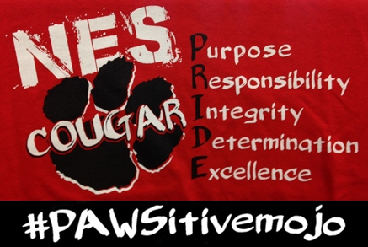
Pre-Order
Sept. 9-21
$14 cash or check
Adult sizes $17
Please make checks payable to: Newport Elementary School

Grade: 3rd 4th

Students Name:___________________________

Homeroom: ______________________________
Shirt Size: (circle one)

Youth: SMALL MEDIUM

LARGE XL

Adult: SMALL MEDIUM

LARGE XL XXL

Date delivered_______

