GRADE 6
English Language Arts
LESSON 6
Wednesday, April 1 and Thursday, April 2

- Look at the picture and read the writing prompt below:

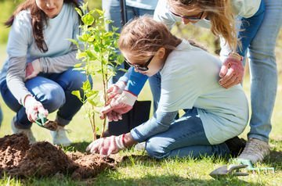

READ: Reread parts of the text, “Carmelo Anthony delivers supplies to 4 Houston-area elementary schools” from earlier in the week.

THINK: Think about what Carmelo Anthony did to help the elementary schools of Houston.

WRITE: Write an essay telling about what you would do to help others and explain why it would be important.

- Write the essay in your Reader’s and Writer’s Notebook. It should be a minimum of three paragraphs.

- READ (anything you want—even product labels count) for a minimum of 15 minutes/day. Keep track of everything that you read in your Reader’s and Writer’s Notebook. I can’t wait to hear all about it!

