GRADE 6
English Language Arts
LESSON 4
Wednesday, March 25 and Thursday, March 26

- Look at the pictures below:

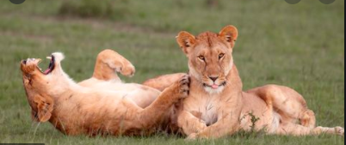

- Select one of the pictures to write about. You will be using the photograph to inspire a story.

- Turn to a new page (or use a new sheet of paper) in your Reader’s and Writer’s Notebook. Divide the page into two columns and label them like the example below:

What I See and Think | My Story

- In the column labeled What I See and Think, make a list of what you see in the photograph (minimum of 6 things) and what you think is happening in the photograph.

- In the column labeled My Story, write a complete story inspired by the photograph using the See and Think column to help you. Your story can be more than one column. You can use the back of your paper or a new sheet of paper, if needed, to complete your story. Be sure that your story has a complete beginning, middle and end.

- READ (anything you want—even product labels count) for a minimum of 15 minutes/day. Start keeping track of everything that you read in your Reader’s and Writer’s Notebook. I can’t wait to hear all about it!

