**Rockets' Carmelo Anthony delivers supplies to 4 Houston-area elementary schools**

*By*[*Jonathan Feigen*](https://www.chron.com/author/jonathan-feigen/)*, Houston Chronicle; Published 7:42 pm CDT, Thursday, October 25, 2018*

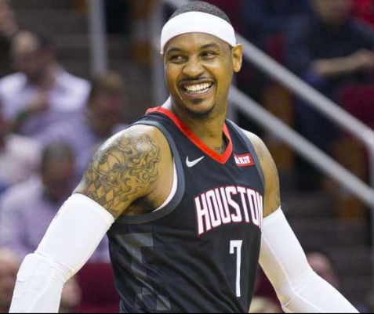

Rockets forward Carmelo Anthony had his first Carmelo Anthony Foundation Tools for Teachers event in Houston on Thursday, contributing supply packs to 150 teachers from Bonham, Fondren, Foerster and Looscan elementary schools.

"Tools for Teachers was truly near and dear to me for the simple fact we all know how hard it is for teachers to go out there and serve as chaperones, serve as parents, serve as friends and still try to be a teacher with not a lot of supplies," Anthony said. "This was an easy one to pick the teachers and let them know me and my foundation are not going to forget them.

“It makes me feel good knowing I can **incorporate** myself into those communities, by doing something that means something, giving back. Yeah, the basketball courts are great. But I think our teachers need a lot of support. I don't think they get enough support. Also, if you support the teachers, you support the kids, too. This is my first of many here in Houston."

The Carmelo Anthony Foundation has built 12 basketball courts in New York, Puerto Rico and South Africa, with Anthony hoping the next court will be built in Houston.

**DIRECTIONS**

1. **Read the passage and answer the questions in your Reader’s and Writer’s Notebook.**
2. **READ (anything you want—even product labels count) for a minimum of 15 minutes/day. Keep track of everything that you read in your Reader’s and Writer’s Notebook. I can’t wait to hear all about it!**
3. Which sentence best supports the idea that Carmelo Anthony’s idea for Tools for Teachers was a practical solution to the problem?
4. What is the meaning of the word **incorporate** in paragraph 3?
5. What idea is developed in this selection?
6. Why does Carmelo Anthony hope to continue to give back to teachers?
7. What is the best summary of this selection?